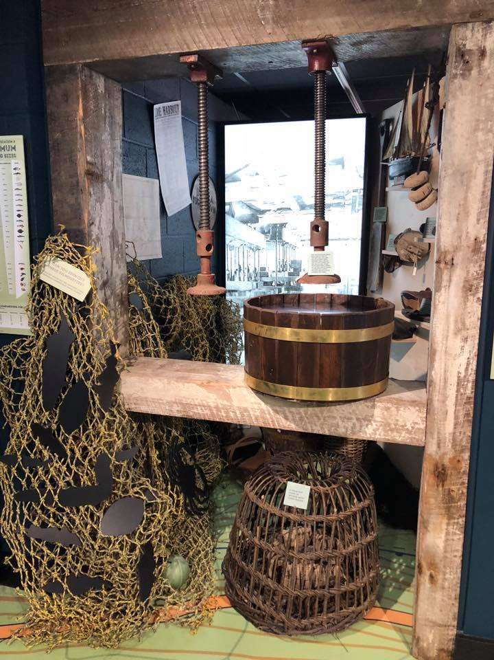
Opened to the public on 3rd July 2018, Looe Harbour Commissioners are proud to present the ‘Old Sardine Factory’ in West Looe.
The building houses a Heritage Centre, Restaurant, Café and Climbing Wall as well as four brand new Fishermen’s Stores on the top floor.
At Old Sardine Factory we offer full or half day educational activity days for young people. These workshops can be tailored to your group, and complement the curriculum through the different Key Stages.
For all activity days, we offer a tour of our brand new, state of the art Heritage Centre, paired with one of the following workshop options for a half day workshop.

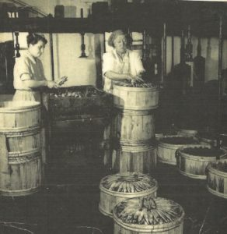
Heritage Centre School Tours
Delve into the rich history of Looe Harbour and those who lived and worked there. Our staff will give students a guided tour around the brand new Heritage Centre. The tour will include;
-Building Looe

Going back in time to the very beginnings of Looe when East Looe and West Looe were separate towns, and how they came together.
- Joseph Thomas: The Man who built Looe

Learn about the Cornish architect and entrepreneur who designed and built many of the landmarks you see in Looe today.

- Trade and Industry
Learn more about the history of fishing in Looe and the different types of fishing boats over the years and find out about sardines and the fishermen who caught them.

- Boat Building
Find out about the history of boat building in Looe and the types of boats that were made.

-Harbour Life
Learn about the people who live and work in the harbour, along with finding out more about the RNLI Lifeboats.

Curriculum links: History/Geography – Chronological understanding, Historical enquiry, Knowledge and understanding of places.
Local Primary Links: Seasons of Looe, The Seaside Past and Present

Boats and Bridges
This workshop looks at the history of East and West Looe and the bridge that connects them. Pupils will learn about the Looe River and how it has been affected over the years. It will also look at the geographical effects of harbour life upon the river, along with tides and flooding, and how Looe is planning to tackle the issue.
Pupils will get the chance to build their own bridges and boats in our ‘Stay Dry Challenge’.
Curriculum links: History/Geography/D&T – Exploring and discovering ideas, understanding development of the area, teamwork, building structures
Working Harbour
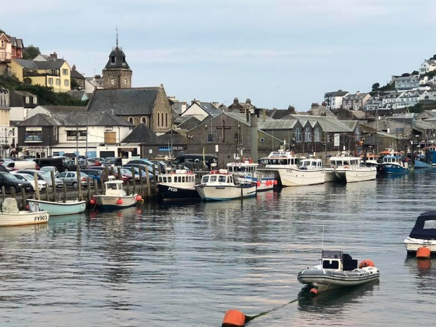
Learn how the businesses within Looe Harbour and the fishing industry has changed over the years, and how the harbour plays an important role in Looe’s economy and in the future of the town. They will also look at how to be safe in a working Harbour.
Pupils will identify various places of interest and transport links on maps, create their own ‘Harbour Guide’ and create a fact file on a person or job role within the harbour.
Looe Heritage Trails are also available.
Curriculum links: History/Geography/Business Studies – Map reading, understanding the local economy, art and design skills, researching and presentation skills.

Dance/drama workshops
Use our Heritage Centre as a stimulus for your students to create site specific pieces of dance or drama around the themes of fishing, harbour life, or rescues at sea.
Workshops will include research tasks, warm up activities and an opportunity for students to perform their works in the Heritage Centre either to each other or to parents and visitors.
Curriculum links: Performing Arts/Dance/Drama – Composing dances showing clear intention, expressing characteristics and emotions effectively, creating narration to tell a story, devising, research.

Booking information
A half day (3 hour) Heritage Centre tour and workshop package will cost £3 per child (teachers and helpers free of charge).
We are happy to customise workshop content to suit your group, so please give us as much information about your students as possible so that we can create a bespoke workshop for your school group.
This offer is also open to any youth groups.
If your group requires lunch, these can be pre-booked through The Sardine Factory Restaurant, please contact us for more information. Students are welcome to bring a packed lunch.
We are a fully accessible venue.
For more information or to book contact Rachel Bond, Heritage Centre Manager
Email: manager@oldsardinefactory.com
Telephone: 01503 264 223.
Information and booking forms can be downloaded from the website www.oldsardinefactory.com

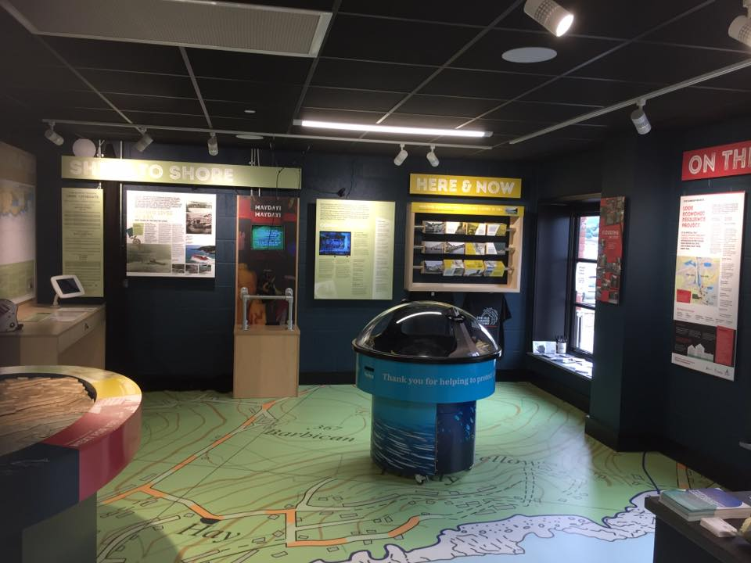

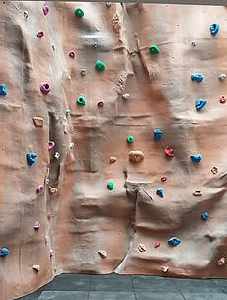
Get active!
Our half day Heritage Centre sessions can be paired up with an activity session with Adventure Fit Southwest.
Curriculum link: These activities complement Physical Education syllabus’ as well as DofE awards or regular school clubs.
Climbing Wall @ Looe
There are 6 roped climbs, and a low level traversing wall. Suitable for beginners or the more experience climber looking for a quiet indoor wall to practice and enhance their skills. There are automatic belay units on 3 climbs, including a chimney climb.

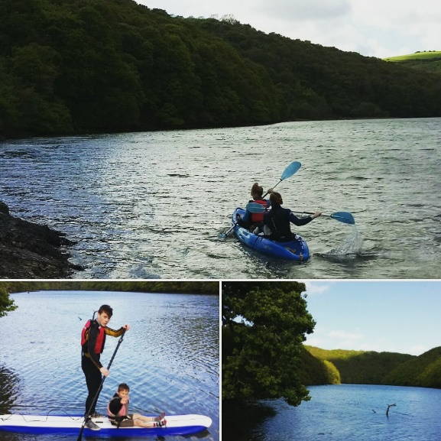
Water based adventure
Canoeing, Kayaking and Paddle Boarding lessons, trips and adventure days!
All within the Looe area, either on the river or along the shoreline.

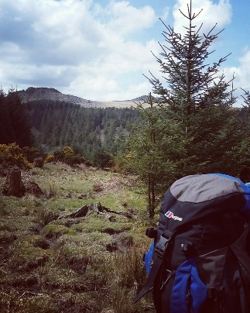

Land based adventure
Adventure Fit South West also run courses and family sessions in hill walking, navigation, camping, bush craft and outdoor climbing.
Contact Paul for more information on activities and prices.
Tel: 01503 262 000 Website: www.adventurefitsouthwest.co.uk

